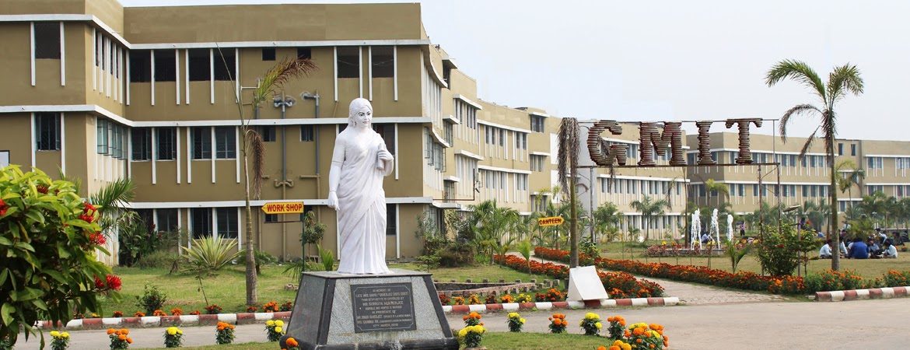

GARGI MEMORIAL INSTITUTE OF TECHNOLOGY

**Group Members: Shubhranil Chowdhury,Soumyajit Barick,Tanushree Ghosh,MD Sabbir Hossain Gazi**

**Stream:Computer Science and Engineering**

**Year-3rd Semister:5th**

**Project Name:Pet Adoption Portal**

**Session: Php and my sql database**

**SUBJECT CODE- ESC 591**

INDEX:

|  |  |  |
| --- | --- | --- |
| SL NO. | Topic | Page No. |
| 1 | Introduction | 3 |
| 2 | Data Flow Diagram | 4 |
| 3 | Website Screenshot | 5-7 |
| 4 | Code | 8-9 |
| 5 | MYSQL Database | 10-11 |
| 6 | Group Members | 11 |
| 7 | Acknowledgement | 12 |

**1. Introduction:**

The **Pet Adoption Portal** is an online platform designed to facilitate the adoption of pets from animal shelters or rescue organizations. The system allows animal shelters (administrators) to manage pet listings, while users (adopters) can browse available pets, submit adoption requests, and track the status of their applications. This project is implemented using **PHP** for server-side scripting and **MySQL** for database management.

**2. Purpose of the System**

The primary purpose of the **Pet Adoption Portal** is to:

1. Provide a user-friendly interface for animal shelters to list and manage adoptable pets.
2. Allow users (potential adopters) to browse, search, and filter pets based on their preferences.

**3.Admin features:**

**1.Pet Management**: Admins can add, edit, and delete pet profiles.

**2.Manage Adoption Requests**: Admins can view, approve, or reject adoption requests.

Data flow diagram:

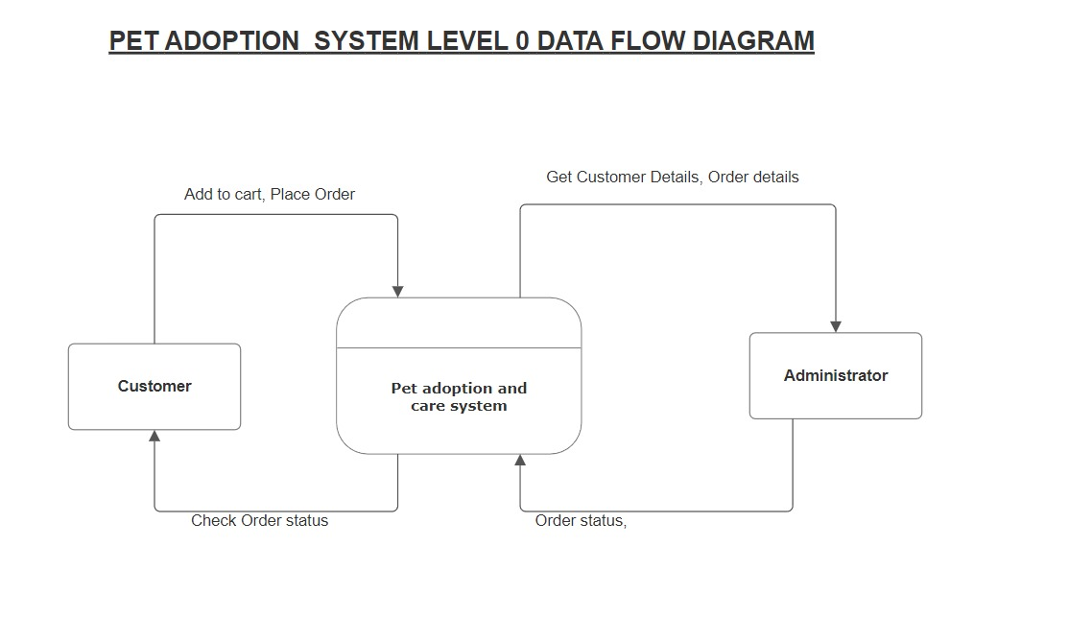

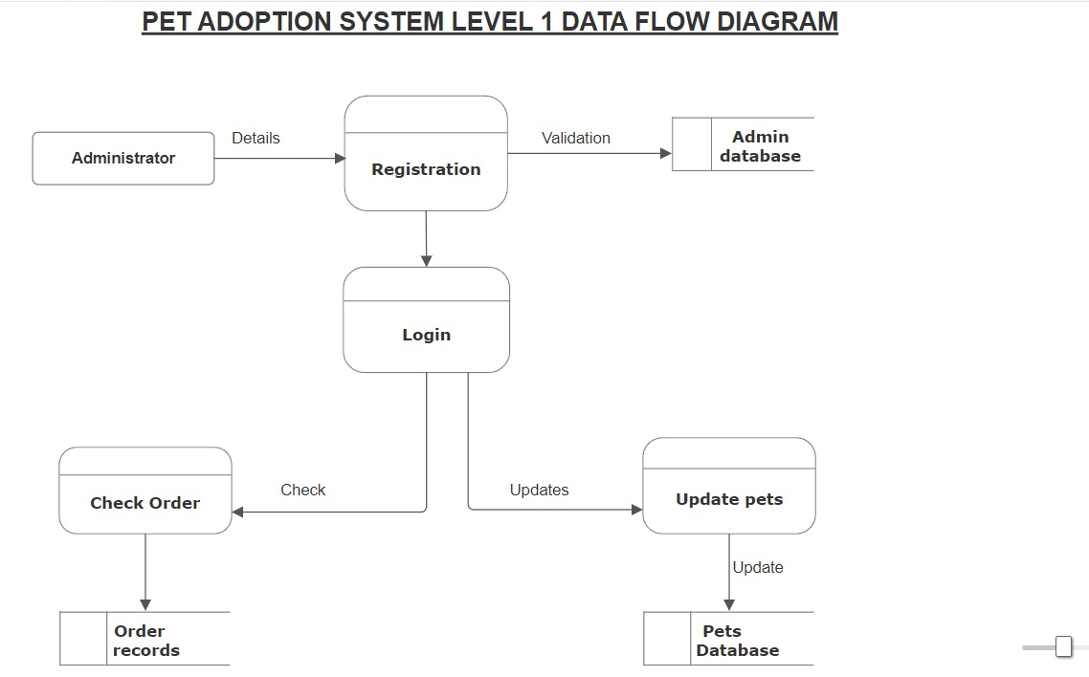

OUR PET ADOPTION PORTAL:

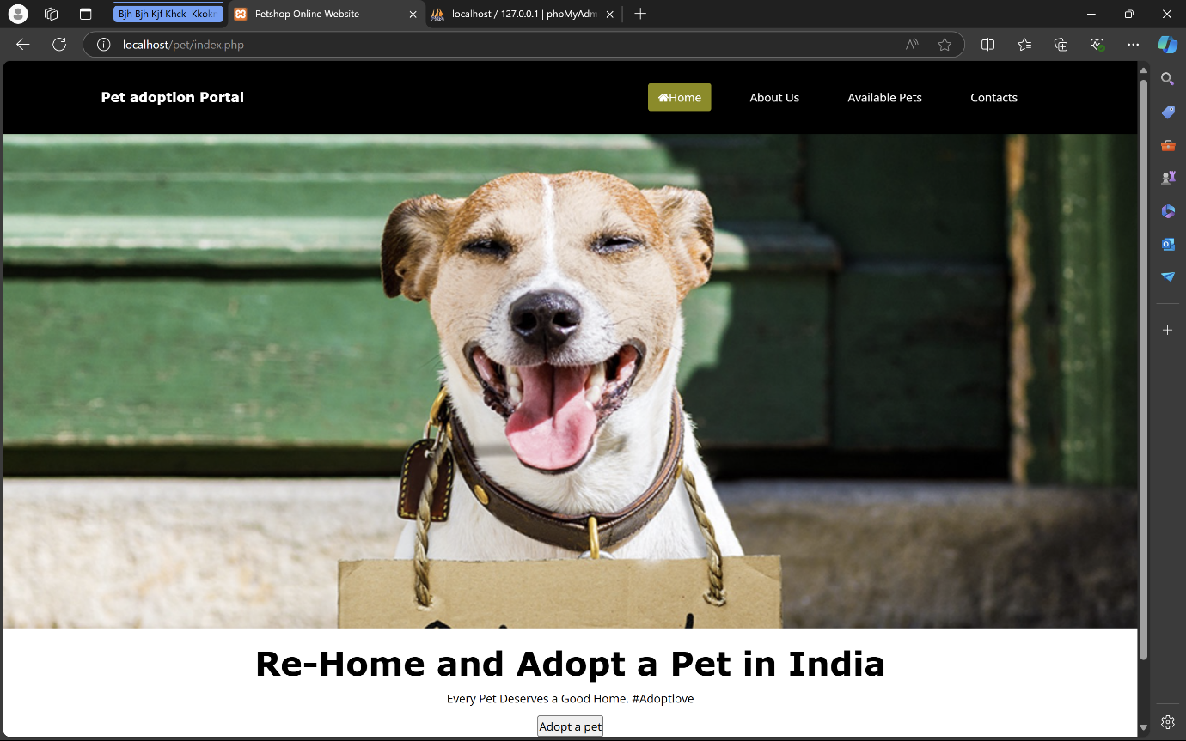

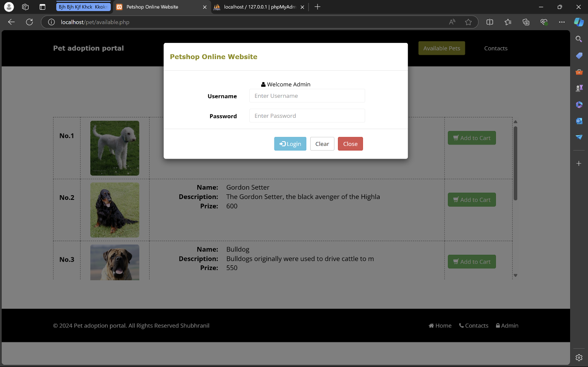

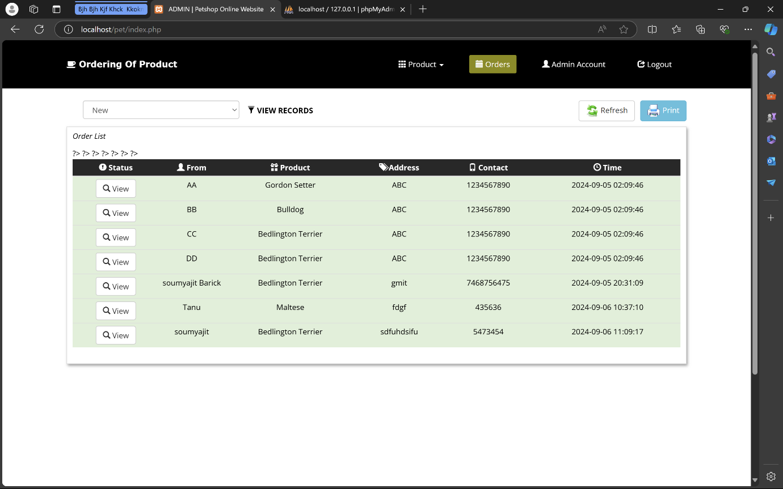

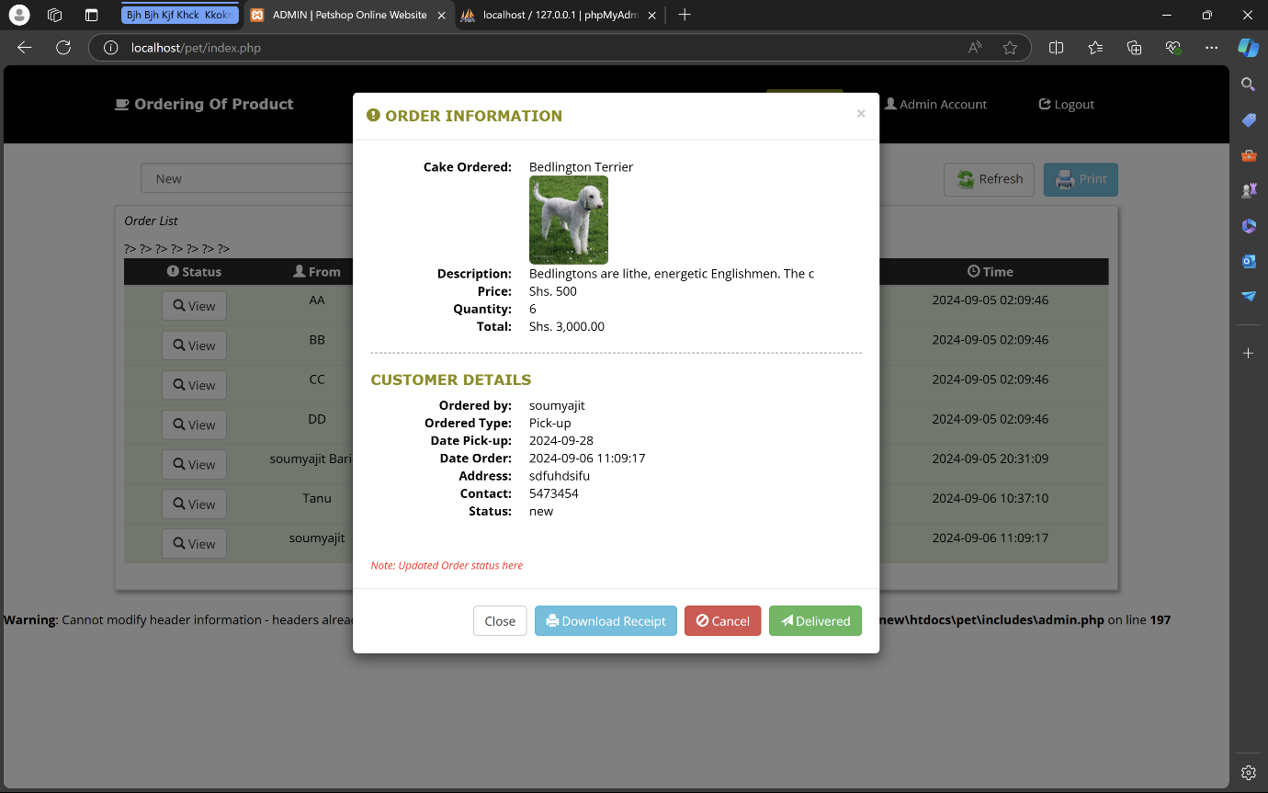

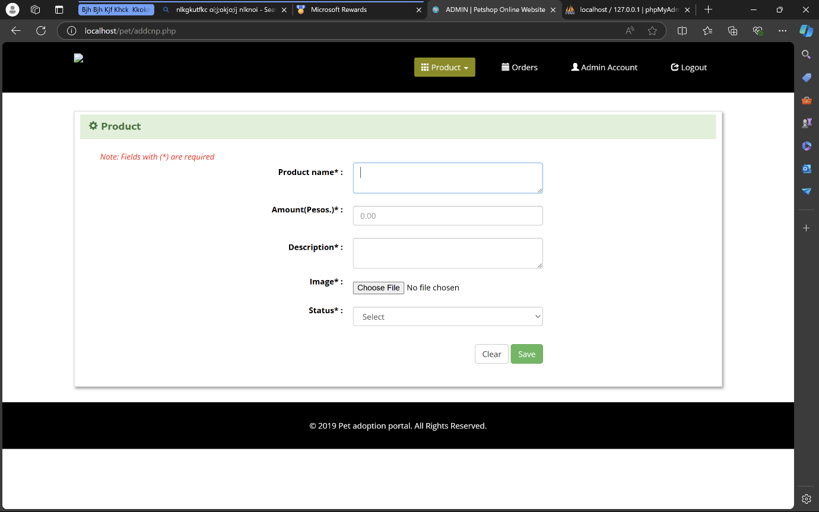

Code:

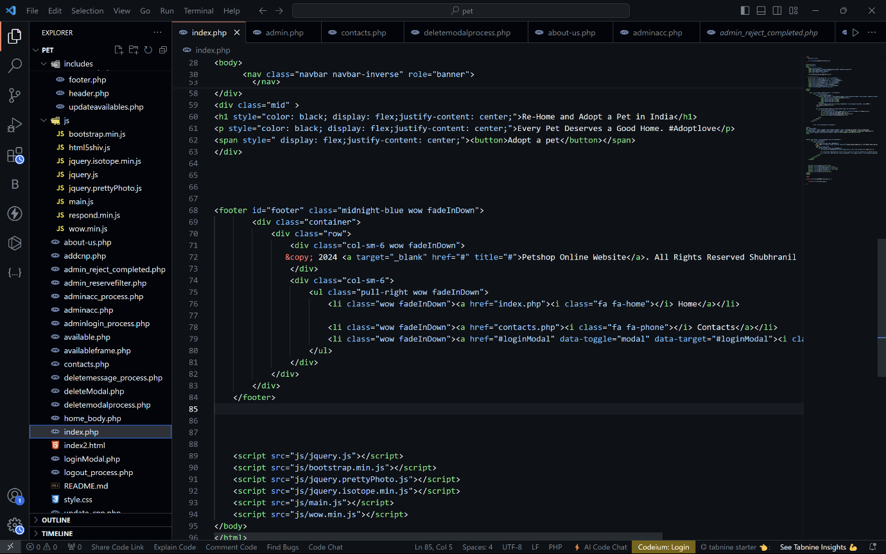

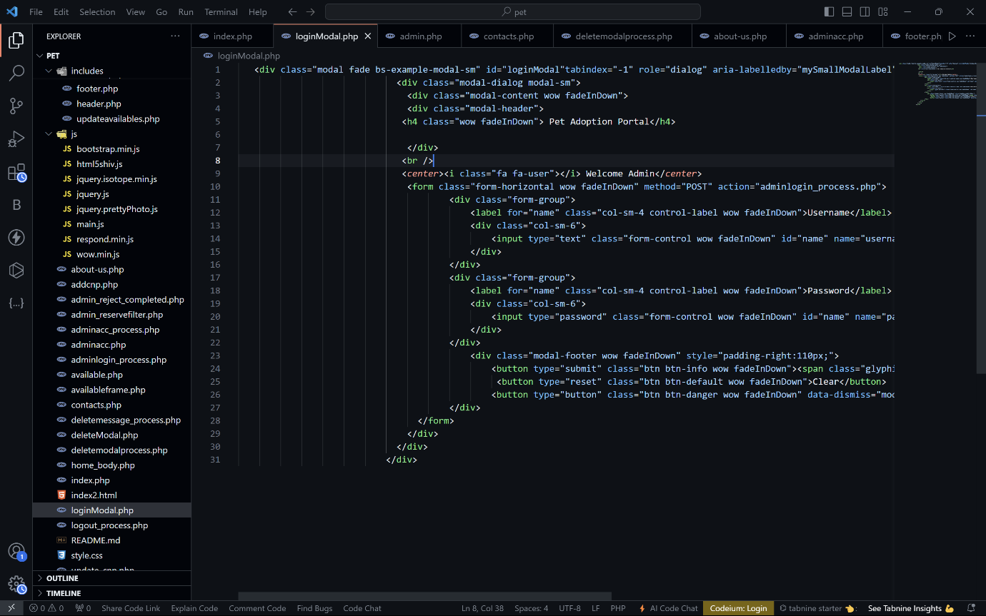

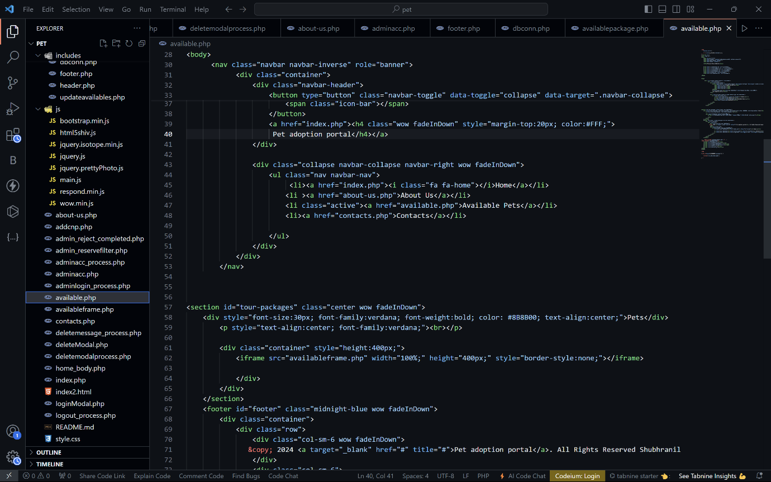

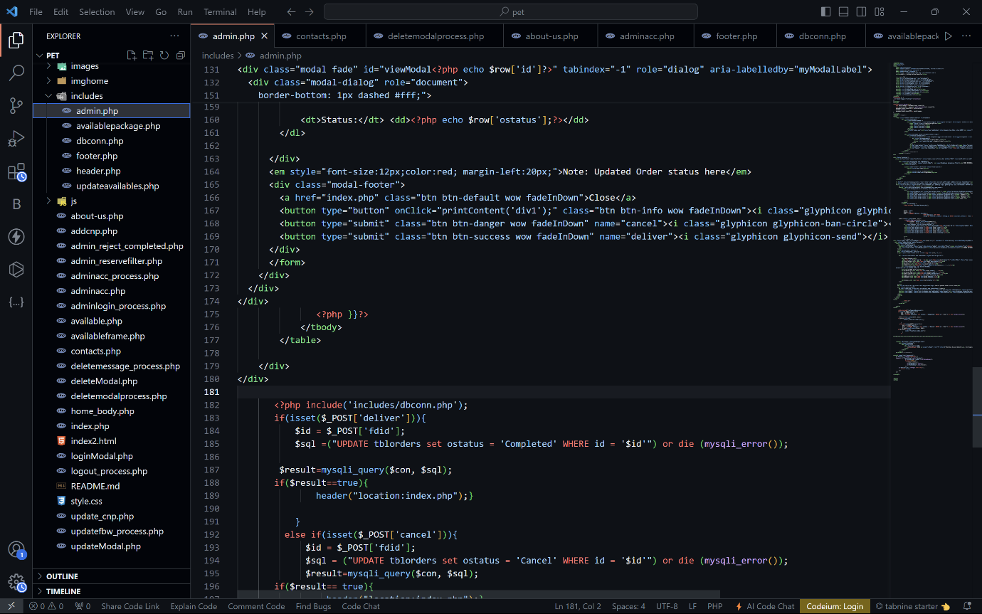

MY SQL DATABASE:

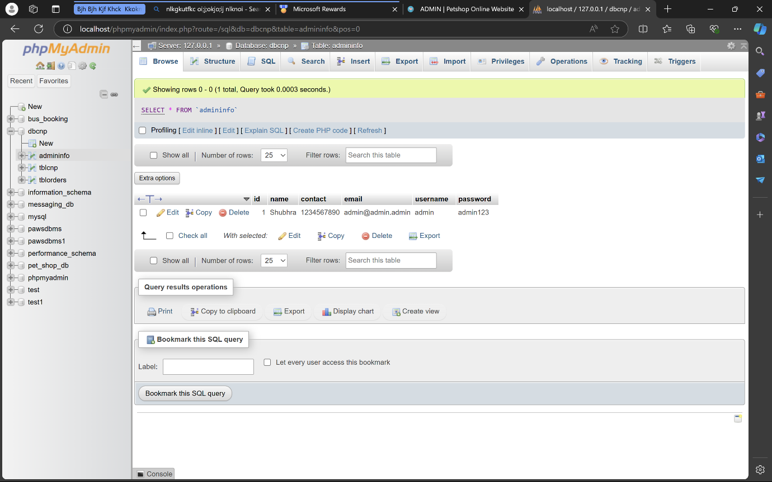

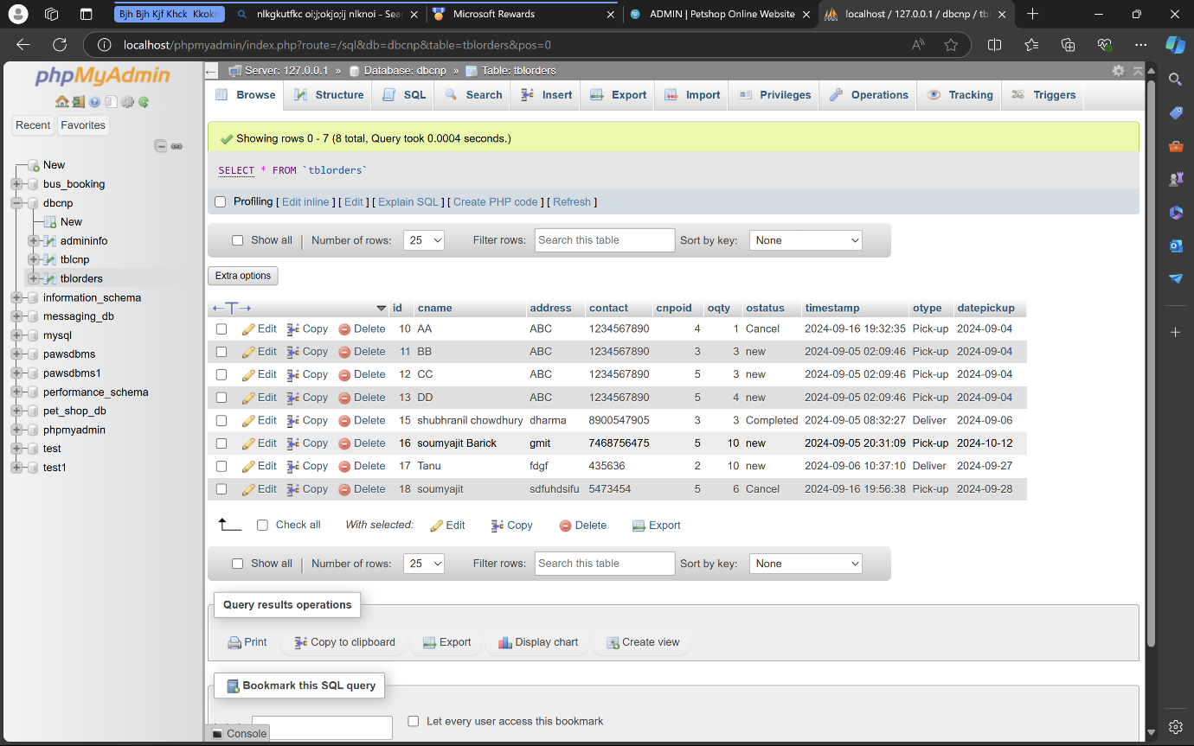

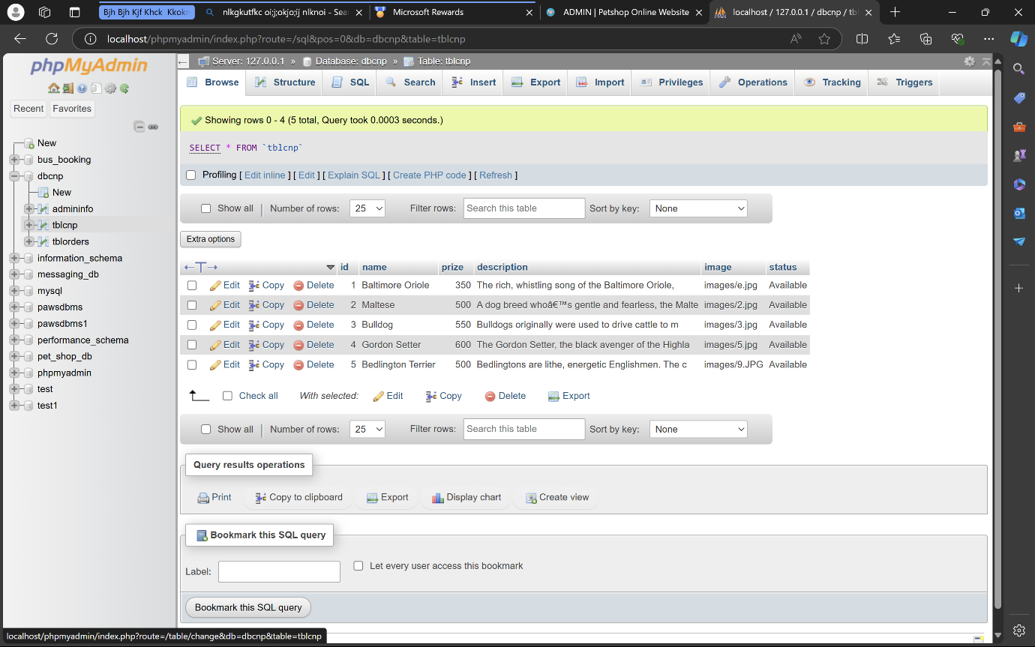

**Group Members of Project- “PET ADOPTION PORTAL”**

**GROUP MEMBER NAMES:**

* **SHUBHRANIL CHOWDHURY (CSE 3RD YEAR)**
* **SOUMYAJIT BARICK (CSE 3RD YEAR)**
* **TANUSHREE GHOSH (CSE 3RD YEAR)**
* **MD SABBIR HOSSAIN GAZI (CSE 3RD YEAR)**

**Acknowledgement:**

* We, the project team, would like to express our sincere gratitude to all those who contributed to the successful completion of this **PET ADOPTION PORTAL** project.
* First and foremost, we would like to thank our college, **Gargi Memorial Institute of Technology** for providing us with the opportunity and platform to work on this project, which has significantly enhanced our knowledge and skills in software development.
* We are deeply grateful to our Project Guide, **Somnath Barik** Sir, for their continuous guidance, valuable insights, and constructive feedback throughout the duration of this project. Their expertise and mentorship have been instrumental in shaping the direction and outcome of our work.
* We would also like to acknowledge the support and encouragement from the faculty and staff members of **the Computer Science and Engineering department** whose advice and technical assistance were pivotal at various stages of our project.
* Additionally, we extend our appreciation to our family and friends for their understanding and support during the project timeline.
* Last but not least, we are thankful for the collaborative efforts of our team members, **Shubhranil Chowdhury,Soumyajit Barick,Tanushree Ghosh,MD Sabbir Hossain Gazi** for their dedication, hard work, and teamwork. Without their commitment and enthusiasm, this project would not have been possible.